API Testing Documentation
Project: COMP 74 Group Project (Library Management System)
Team Members:
1. Overview
This document outlines the manual testing procedures performed on the Library Management API. Testing was conducted using Postman to verify that all RESTful endpoints support full CRUD operations, handle data validation correctly, and return the appropriate HTTP status codes.

2. Test Environment
- Base URL: http://localhost:3000
- Tool Used: Postman
- Database State: SQLite database with sample data.

3. Test Cases
Test Case 1: Retrieve All Books (Read)
- Method: GET
- Expected Result: A 200 OK status code and a JSON array containing the library's books
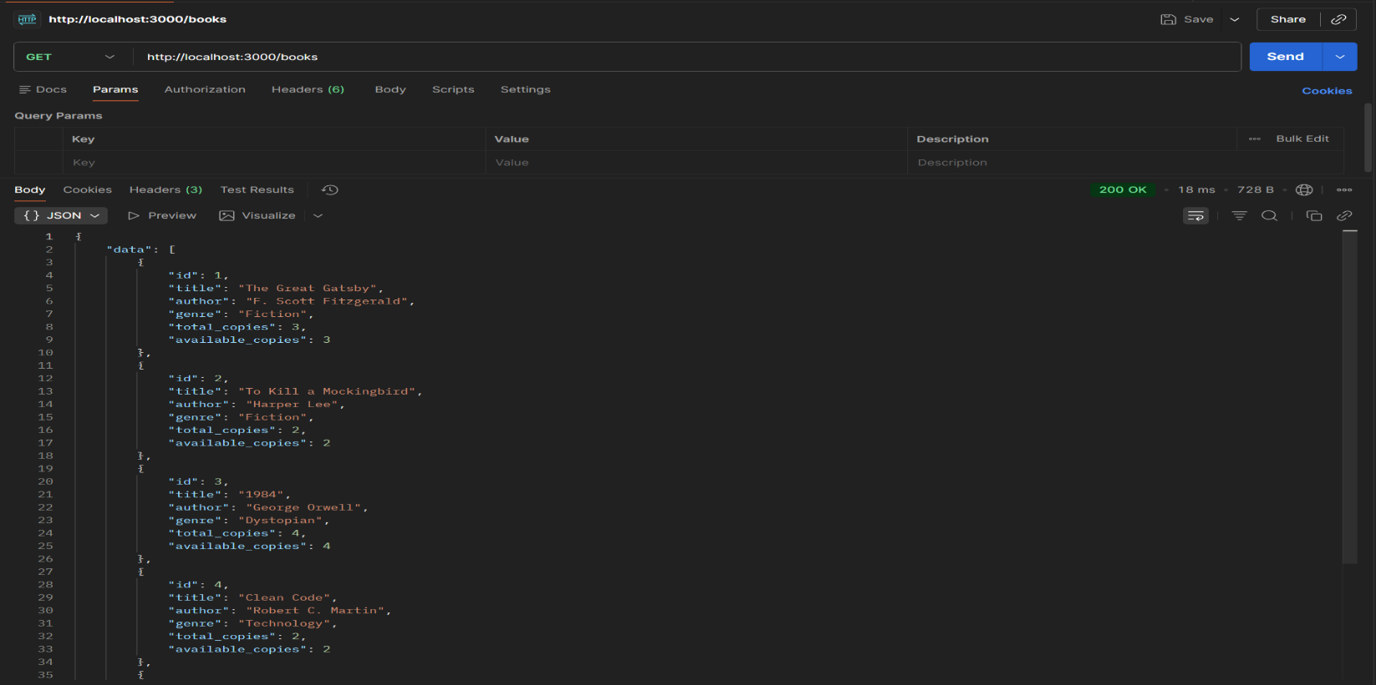
- Result:

Test Case 2: Register a New Member (Create)
- Method: POST
- Request Body (JSON):
{
"name": "Nishil Sailor",
"email": "nishil@email.com",
"phone": "897-481-4984"
}
- Expected Result: A 201 Created status code and a response showing the newly created member.
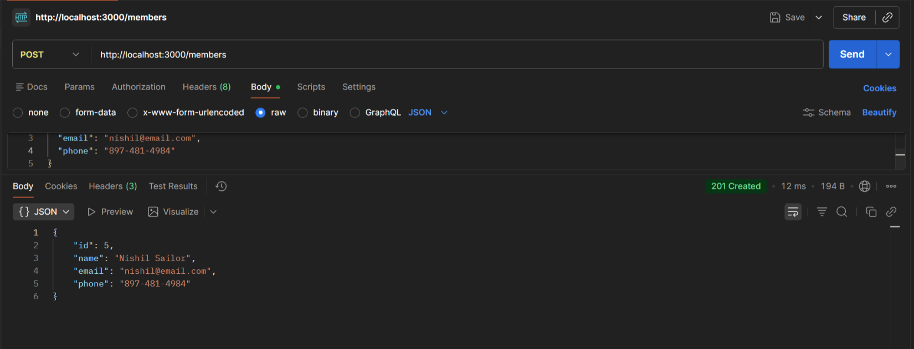
- Result:

Test Case 3: Checkout a Book
- Method: POST
- Request Body (JSON):
{
"book_id": 1,
"member_id": 5
}
- Expected Result: A 201 Created status code, a new loan record with today's date.
- Result:

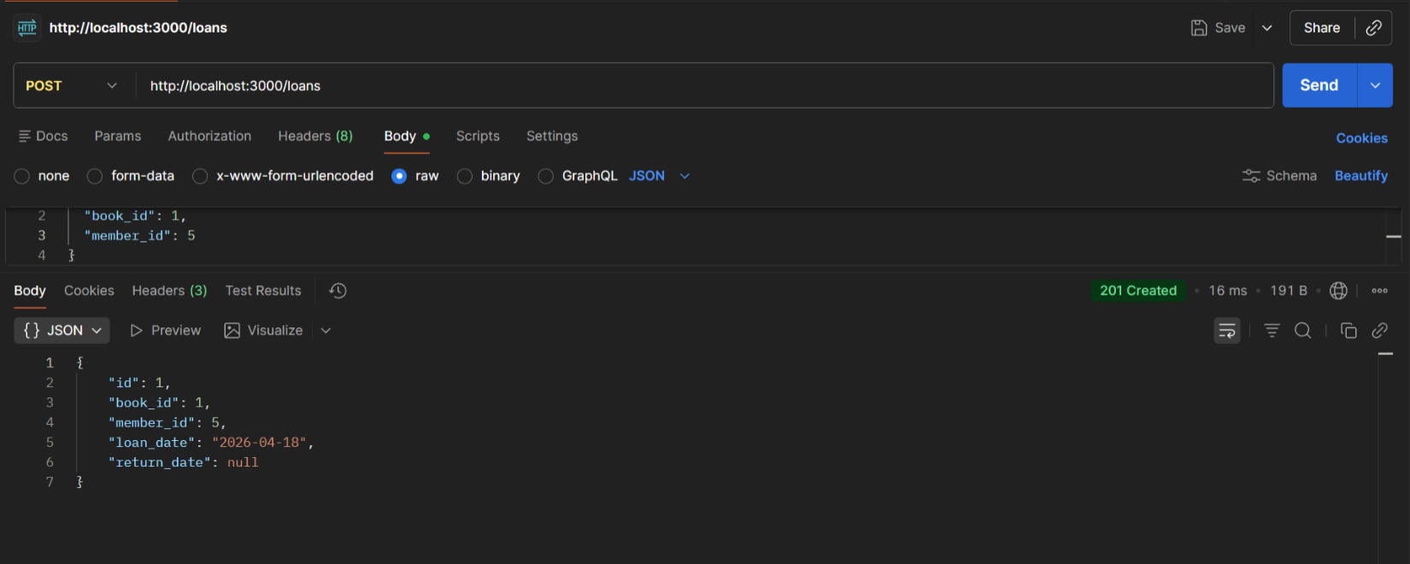

Test Case 4: Return a Book (Update)
- Method: PUT
- Request Body: Empty JSON object {}
- Expected Result: A 200 OK status code, the loan record updated with today's return date.
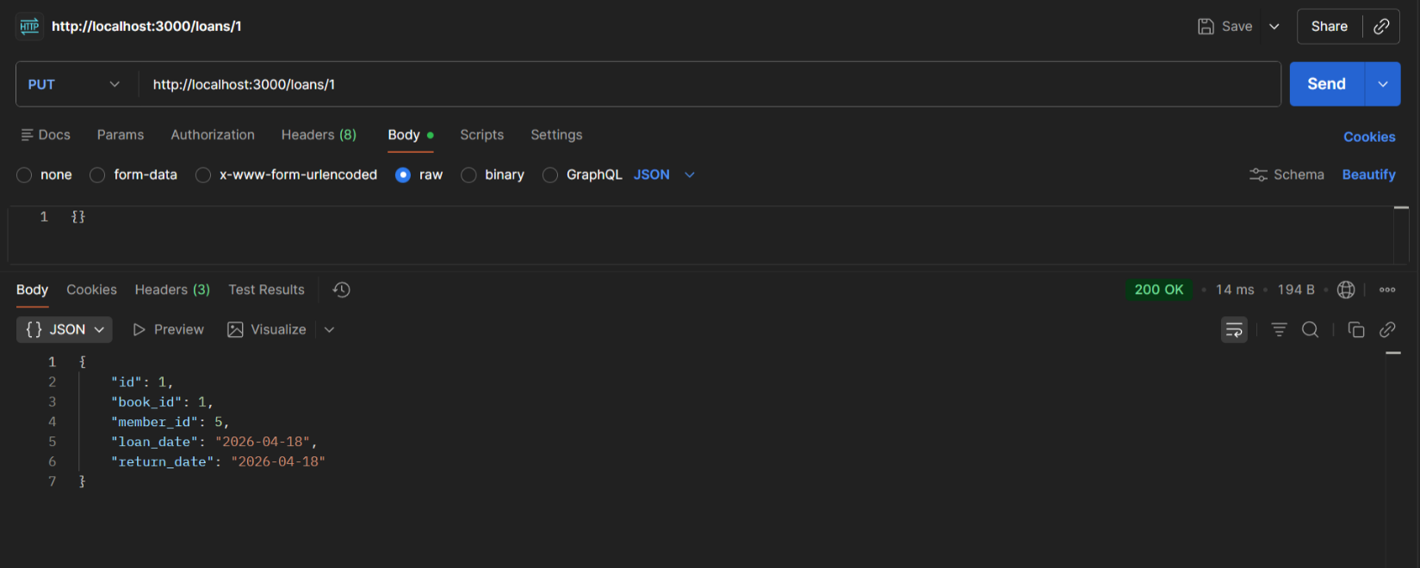
- Result:

Test Case 5: Remove a Member (Delete)
- Method: DELETE
- Expected Result: A 200 OK status code with a successfully deleted message.
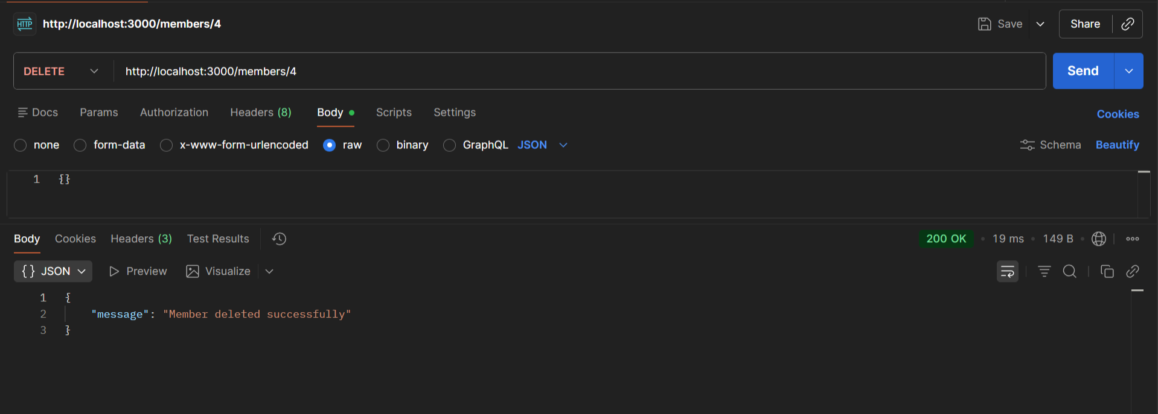
- Result:

